**Pertemuan 2 : CSS**

**Tugas 2 : W-BANK**

|  |  |
| --- | --- |
| **Nama / Nim** | **: NAYURA ARSINEDA (2218022)** |
| **Kelas** | **: B** |
| **Pengajar** | **: ELLOK ANANDA MADYA PRATIWI** |

* 1. **Tujuan**

1. Praktikan mampu memahami struktur dasar CSS.
2. Praktikan mampu memahami dasar – dasar CSS.
3. Praktikan dapat menghubungkan antara HTML dengan CSS.
   1. **Alat dan Bahan**
4. Laptop/pc
5. Modul Praktikum Web 2024
6. TextEditor (Visual Studio Code / Sublime Text)
   1. **Langkah-langkah**
7. index.html

*Source code* :

|  |
| --- |
| <!DOCTYPE html>  <html lang="en">  <head>  <meta charset="UTF-8">  <meta http-equiv="X-UA-Compatible" content="IE=edge">  <meta name="viewport" content="width=device-width, initial-scale=1.0">  <title>W-Banking - Home</title>  <style>  body {  margin: 0;  padding: 0;  font-family: 'Goudy Bookletter 1911', serif;  background: url('5.jpg') no-repeat center center fixed;  background-size: cover;  height: 100vh;  display: flex;  justify-content: center;  align-items: center;  text-align: center;  }  .overlay {  background-color: rgba(255, 255, 255, 0.9);  padding: 30px;  border-radius: 10px;  box-shadow: 0 4px 6px rgba(0, 0, 0, 0.1);  max-width: 800px;  width: 90%;  }  h1 {  font-size: 3em;  margin-bottom: 20px;  color: #333;  text-shadow: 2px 2px 4px rgba(0, 0, 0, 0.2);  }  p {  font-size: 1.5em;  margin-bottom: 30px;  color: #555;  }  a {  text-decoration: none;  color: #fff;  background-color: #333;  padding: 15px 30px;  border-radius: 5px;  margin-right: 10px;  transition: all 0.3s ease;  }  a:hover {  background-color: #555;  }  </style>  </head>  <body>  <div class="overlay">  <h1>W-BANK</h1>  <p>Finansial Solutions.</p>  <a href="login.html">Login</a>  <a href="register.html">Register</a>  <a href="admin.html">Admin</a>  </div>  </body>  </html> |

1. login.html

*Source code* :

|  |
| --- |
| <!DOCTYPE html>  <html lang="en">  <head>  <meta charset="UTF-8">  <meta http-equiv="X-UA-Compatible" content="IE=edge">  <meta name="viewport" content="width=device-width, initial-scale=1.0">  <title>MBanking - Login</title>  <style>  body {  margin: 0;  padding: 0;  font-family: 'Goudy Bookletter 1911', serif;  background: url('background.jpg') no-repeat center center fixed;  background-size: cover;  height: 100vh;  display: flex;  justify-content: center;  align-items: center;  text-align: center;  }  .container {  background-color: rgba(255, 255, 255, 0.8);  padding: 30px;  border-radius: 10px;  box-shadow: 0 4px 6px rgba(0, 0, 0, 0.1);  max-width: 400px;  width: 90%;  position: relative;  z-index: 1;  }  h1 {  font-size: 2.5em;  margin-bottom: 20px;  color: #333;  text-shadow: 2px 2px 4px rgba(0, 0, 0, 0.3);  }  form {  margin-bottom: 20px;  }  label {  display: block;  margin-bottom: 5px;  text-align: left;  color: #555;  }  input[type="text"],  input[type="password"] {  width: 100%;  padding: 10px;  margin-bottom: 10px;  border-radius: 5px;  border: 1px solid #ccc;  box-sizing: border-box;  }  input[type="submit"] {  background-color: #007bff;  color: #fff;  padding: 10px 20px;  border: none;  border-radius: 5px;  cursor: pointer;  transition: background-color 0.3s;  }  input[type="submit"]:hover {  background-color: #0056b3;  }  a {  text-decoration: none;  color: #007bff;  margin-top: 10px;  display: inline-block;  margin-right: 10px;  }  img {  width: 100%;  height: auto;  position: absolute;  top: 0;  left: 0;  z-index: 0;  }  </style>  </head>  <body>  <img src="3.jpg" alt="Background Image">  <div class="container">  <h1>Login to W-Bank Account</h1>  <form action="login.php" method="POST">  <label for="username">Username:</label><br>  <input type="text" id="username" name="username"><br>  <label for="password">Password:</label><br>  <input type="password" id="password" name="password"><br>  <input type="submit" value="Login">  </form>  <a href="Landing Page.html">Back</a>  <a href="register.html">Register</a>  </div>  </body>  </html> |

1. register.html

*Source code* :

|  |
| --- |
| <!DOCTYPE html>  <html lang="en">  <head>  <meta charset="UTF-8">  <meta http-equiv="X-UA-Compatible" content="IE=edge">  <meta name="viewport" content="width=device-width, initial-scale=1.0">  <title>MBanking - Register</title>  <style>  body {  margin: 0;  padding: 0;  font-family: Arial, sans-serif;  background-color: #f9f9f9;  display: flex;  justify-content: center;  align-items: center;  min-height: 100vh;  }  .container {  background-color: #fff;  padding: 30px;  border-radius: 10px;  box-shadow: 0 4px 6px rgba(0, 0, 0, 0.1);  max-width: 800px;  width: 90%;  display: grid;  grid-template-columns: 1fr 1fr;  grid-gap: 20px;  }  .form-container {  display: flex;  flex-direction: column;  justify-content: center;  align-items: center;  padding: 20px;  grid-column: 1 / span 1;  }  h1 {  font-size: 2.5em;  margin-bottom: 20px;  color: #333;  }  form {  width: 100%;  }  label {  display: block;  margin-bottom: 5px;  text-align: left;  color: #555;  }  input[type="text"],  input[type="password"],  input[type="email"] {  width: 100%;  padding: 10px;  margin-bottom: 10px;  border-radius: 5px;  border: 1px solid #ccc;  box-sizing: border-box;  }  input[type="submit"] {  background-color: #007bff;  color: #fff;  padding: 10px 20px;  border: none;  border-radius: 5px;  cursor: pointer;  transition: background-color 0.3s;  }  input[type="submit"]:hover {  background-color: #0056b3;  }  a {  text-decoration: none;  color: #007bff;  margin-top: 10px;  display: inline-block;  margin-right: 10px;  }  .image-container {  border-radius: 10px;  overflow: hidden;  grid-column: 2 / span 1;  position: relative;  }  .image-container img {  width: 100%;  height: 100vh;  object-fit: cover;  filter: grayscale(80%);  transition: filter 0.3s;  }  .image-container:hover img {  filter: grayscale(0);  }  .overlay {  position: absolute;  top: 0;  left: 0;  width: 100%;  height: 100%;  background-color: rgba(0, 0, 0, 0.5);  display: flex;  justify-content: center;  align-items: center;  opacity: 0;  transition: opacity 0.3s;  }  .overlay:hover {  opacity: 1;  }  .overlay-content {  text-align: center;  color: #fff;  }  .overlay-content h2 {  font-size: 2em;  margin-bottom: 10px;  }  .overlay-content p {  font-size: 1.2em;  }  </style>  </head>  <body>  <div class="container">  <div class="form-container">  <h1>Register</h1>  <form action="register.php" method="POST">  <label for="username">Username:</label><br>  <input type="text" id="username" name="username"><br>  <label for="password">Password:</label><br>  <input type="password" id="password" name="password"><br>  <label for="email">Email:</label><br>  <input type="email" id="email" name="email"><br>  <input type="submit" value="Register">  </form>  <a href="login.html">Login</a>  </div>  <div class="image-container">  <img src="cc2.jpg" alt="Register Image">  <div class="overlay">  <div class="overlay-content">  <h2>YOUR TEMPLATE CREDIT CARD</h2>  <p>W-BANK Financial Solution</p>  </div>  </div>  </div>  </div>  </body>  </html> |

Hasil Tampilan

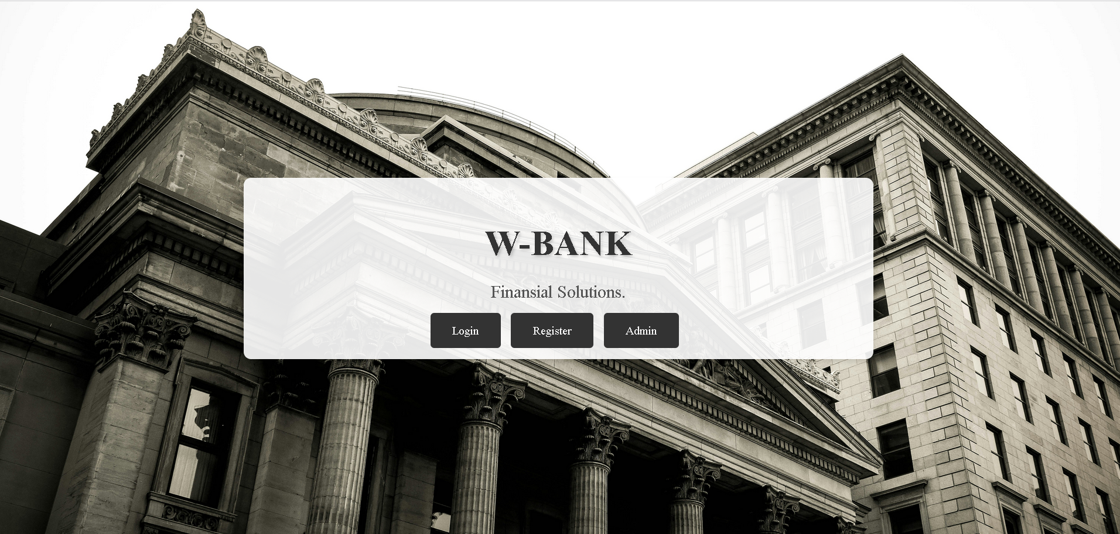

Gambar 1.1 Tampilan Halaman Home

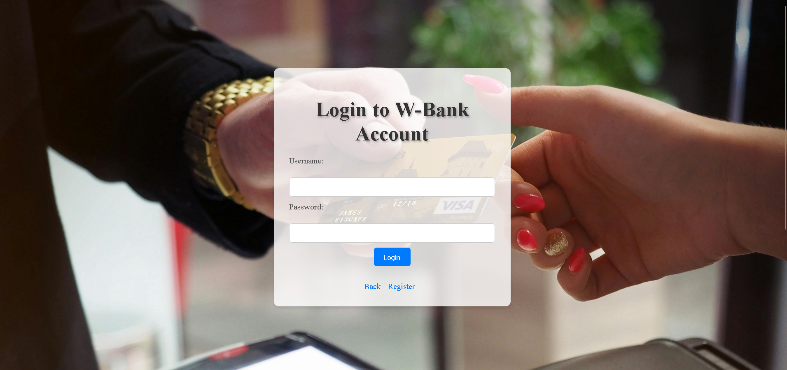

Gambar 1.2 Tampilan Login

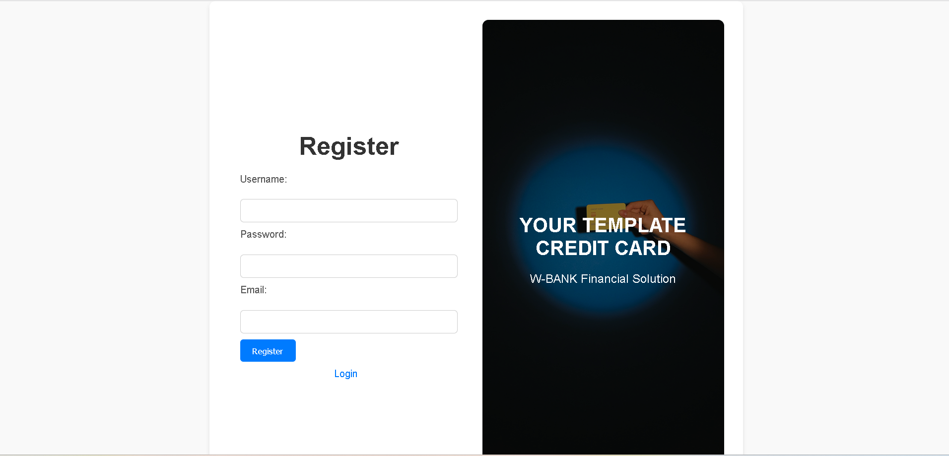

Gambar 1.3 Tampilan Register

Analisa :

Kode di atas merupakan bagian dari halaman web untukW-BANK. Halaman ini menu untuk berpindah antara halaman utama, login, register dan admin. Form login memungkinkan pengguna untuk memasukkan username, password. Jika user memilih register maka aka nada tampilan register, dan pilihan admin akan masuk ke dashboard

1. admin.html

*Source code* :

|  |
| --- |
| <!DOCTYPE html>  <html lang="en">  <head>  <meta charset="UTF-8">  <meta http-equiv="X-UA-Compatible" content="IE=edge">  <meta name="viewport" content="width=device-width, initial-scale=1.0">  <link rel="stylesheet" href="admin.css">  <title>Admin Dashboard</title>  </head>  <body>  <div class="sidebar">  <div class="logo-details">  <img src="wall2.png" alt="W-Bank Logo"> <!-- Gambar Logo -->  <span class="logo_name">W-Bank</span>  </div>  <ul class="nav-links">  <li>  <a href="#" class="active">  <i class="bx bx-grid-alt"></i>  <span class="links_name">Dashboard</span>  </a>  </li>  <li>  <a href="categories.html" class="menu-link">  <i class="bx bx-box"></i>  <span class="links_name">Categories</span>  </a>  </li>  <li>  <a href="transaction.html" class="menu-link">  <i class="bx bx-list-ul"></i>  <span class="links_name">Transaction</span>  </a>  </li>  <li>  <a href="index.html">  <i class="bx bx-arrow-back"></i>  <span class="links_name">Back to Home</span>  </a>  </li>  </ul>  </div>  <section class="home-section">  <nav>  <div class="sidebar-button">  <i class="bx bx-menu sidebarBtn"></i>  </div>  <div class="profile-details">  <span class="admin_name">W-Bank Admin</span>  </div>  </nav>  <div class="home-content">  <h1>Welcome Admin</h1>  <p>This is your dashboard. Manage your categories and transactions here.</p>  </div>  </section>  <!-- Input checkbox sebagai trigger pop-up -->  <input type="checkbox" id="popup-toggle">  <!-- Label untuk strip 3 -->  <label for="popup-toggle" class="strip">☰</label>  <!-- Pop-up -->  <div class="popup" id="popup">  <img src="hp.png" alt="iPhone Screen" class="iphone-screen">  </div>  </body>  </html> |

1. admin.css

*Sorce Code :*

|  |
| --- |
| body {  font-family: 'Times New Roman', Times, serif;  margin: 0;  padding: 0;  background-color: #f5f5f5;  }  .sidebar {  position: fixed;  top: 0;  left: 0;  width: 250px;  height: 100vh;  background-color: #000000;  color: #fff;  padding-top: 20px;  }  .logo-details {  text-align: center;  margin-bottom: 20px;  }  .logo-details img {  width: 80%;  margin: 0 auto;  display: block;  margin-bottom: 20px;  }  .logo-details span {  font-size: 24px;  font-weight: bold;  }  .nav-links {  list-style: none;  padding: 0;  margin: 0;  }  .nav-links li {  margin-bottom: 10px;  }  .nav-links a {  display: block;  padding: 10px 20px;  color: #fff;  text-decoration: none;  transition: background-color 0.3s;  }  .nav-links a:hover {  background-color: #555;  }  .active {  background-color: #555;  }  .sidebar-button {  text-align: right;  padding: 10px 20px;  cursor: pointer;  }  .sidebar-button i {  font-size: 24px;  }  .profile-details {  text-align: center;  margin-top: 20px;  padding-bottom: 20px;  border-bottom: 1px solid #888;  }  .home-section {  margin-left: 250px;  padding: 20px;  }  .home-content {  text-align: center;  }  .popup {  display: none;  position: fixed;  z-index: 1;  left: 0;  top: 0;  width: 100%;  height: 100%;  overflow: auto;  background-color: rgba(0,0,0,0.5);  }  .popup-content {  background-color: #fefefe;  margin: 15% auto;  padding: 20px;  border: 1px solid #888;  width: 80%;  max-width: 400px;  border-radius: 5px;  }  .close {  color: #aaa;  float: right;  font-size: 28px;  font-weight: bold;  cursor: pointer;  }  .close:hover,  .close:focus {  color: black;  text-decoration: none;  }  /* CSS untuk menampilkan pop-up saat checkbox checked */  #popup-toggle:checked + .popup {  display: block;  }  .strip {  position: fixed;  bottom: 10px;  left: 10px;  cursor: pointer;  color: white;  font-size: 24px;  }  .strip:hover {  color: #333;  }  /* Tampilan layar ponsel (iPhone) */  .iphone-screen {  max-width: 100%;  height: auto;  margin-top: 20px;  } |

Hasil Tampilan :

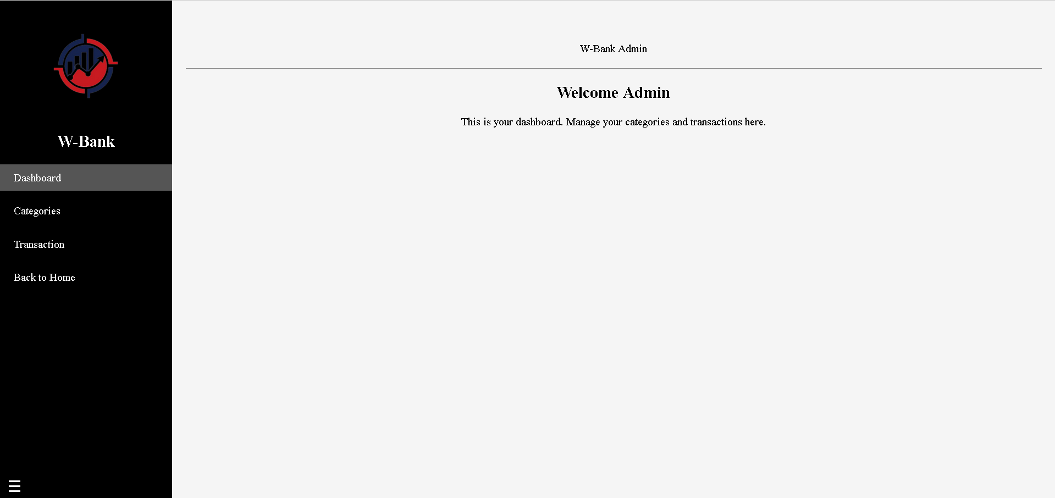

Gambar 1.4 Tampilan admin

Analisa :

Halaman diatas merupakan bagian dari halamanW-BANK. Halaman ini merupakan tampilan awal atau dashboard, ada menu categories, transaction dan back to home yang merupakan kembali ke menu awal.

1. Categories.html

*Source code* :

|  |
| --- |
| <!DOCTYPE html>  <html lang="en">  <head>  <meta charset="UTF-8">  <meta http-equiv="X-UA-Compatible" content="IE=edge">  <meta name="viewport" content="width=device-width, initial-scale=1.0">  <link rel="stylesheet" href="kategori.css">  <title>Categories</title>  </head>  <body>  <div class="container">  <h1>Categories</h1>  <a href="admin.html" class="back-btn">Back to Admin</a>  <table>  <thead>  <tr>  <th>Jenis Kartu</th>  <th>Kategori</th>  <th>Deskripsi</th>  <th>Harga</th>  <th>Action</th>  </tr>  </thead>  <tbody>  <tr>  <td>Silver</td>  <td>Category 1</td>  <td>Deskripsi Category 1</td>  <td>$100</td>  <td>  <button class="edit-btn">Edit</button>  <button class="delete-btn">Delete</button>  </td>  </tr>  <tr>  <td>Gold</td>  <td>Category 2</td>  <td>Deskripsi Category 2</td>  <td>$150</td>  <td>  <button class="edit-btn">Edit</button>  <button class="delete-btn">Delete</button>  </td>  </tr>  <tr>  <td>Platinum</td>  <td>Category 3</td>  <td>Deskripsi Category 3</td>  <td>$200</td>  <td>  <button class="edit-btn">Edit</button>  <button class="delete-btn">Delete</button>  </td>  </tr>  </tbody>  </table>  <button class="add-btn">Tambah Data</button>  </div>  </body>  </html> |

1. categories.css

*Source code* :

|  |
| --- |
| body {  font-family: Arial, sans-serif;  margin: 0;  padding: 0;  background-color: #f2f2f2;  }  .container {  max-width: 1200px;  margin: 50px auto;  padding: 20px;  background-color: #fff;  border-radius: 10px;  box-shadow: 0 0 20px rgba(0, 0, 0, 0.1);  }  h1 {  font-size: 36px;  text-align: center;  margin-bottom: 20px;  color: #333;  }  table {  width: 100%;  border-collapse: collapse;  margin-bottom: 20px;  }  th, td {  padding: 10px;  text-align: left;  }  th {  background-color: #f2f2f2;  border-bottom: 1px solid #ddd;  }  tr:nth-child(even) {  background-color: #f9f9f9;  }  .edit-btn, .delete-btn, .add-btn, .back-btn {  padding: 8px 12px;  margin: 5px;  border: none;  background-color: #333;  color: #fff;  cursor: pointer;  border-radius: 5px;  text-transform: uppercase;  text-decoration: none;  display: inline-block;  }  .edit-btn:hover, .delete-btn:hover, .add-btn:hover, .back-btn:hover {  background-color: #555;  }  button, a {  font-family: Arial, sans-serif;  text-decoration: none;  }  input[type="file"] {  border: none;  background-color: #f2f2f2;  padding: 5px;  border-radius: 3px;  }  input[type="file"]:focus {  outline: none;  background-color: #e0e0e0;  } |

Hasil Tampilan :

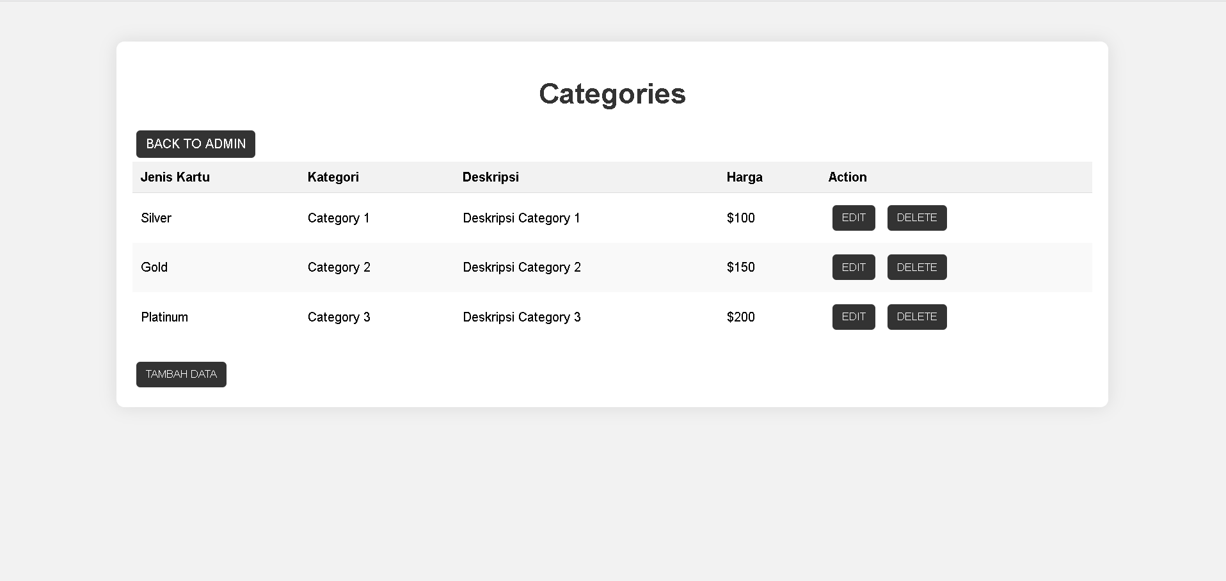

Gambar 1.5 Tampilan categories

Analisa :

Halaman categories berisi beberapa kolom dan table yang menampilkan jenis kartu, kategori, deskripsi, harga dan action, serta ada 2 tombol untuk Kembali ke dashboard atau admin dan tambah data untuk menambah beberapa data lagi.

1. Transaction.html

*Source code* :

|  |
| --- |
| <!DOCTYPE html>  <html lang="en">  <head>  <meta charset="UTF-8">  <meta http-equiv="X-UA-Compatible" content="IE=edge">  <meta name="viewport" content="width=device-width, initial-scale=1.0">  <link rel="stylesheet" href="transaksi.css">  <title>Transactions</title>  </head>  <body>  <div class="container">  <a href="admin.html" class="back-btn">Back to Admin</a>  <h1>Transactions</h1>  <table>  <thead>  <tr>  <th>Nama</th>  <th>Tanggal Transaksi</th>  <th>Jumlah Transaksi</th>  <th>Kategori Transaksi</th>  <th>Status</th>  <th>Action</th>  </tr>  </thead>  <tbody>  <tr>  <td>John Doe</td>  <td>2022-04-01</td>  <td>$100</td>  <td>Food</td>  <td>Pending</td>  <td>  <button class="edit-btn">Edit</button>  <button class="delete-btn">Delete</button>  </td>  </tr>  <tr>  <td>Jane Smith</td>  <td>2022-04-02</td>  <td>$50</td>  <td>Transportation</td>  <td>Completed</td>  <td>  <button class="edit-btn">Edit</button>  <button class="delete-btn">Delete</button>  </td>  </tr>  <!-- Tambahkan data transaksi lainnya di sini -->  </tbody>  </table>  </div>  </body>  </html> |

1. transaction.css

*Source code* :

|  |
| --- |
| body {  font-family: Arial, sans-serif;  margin: 0;  padding: 0;  background-color: #f2f2f2;  }  .container {  max-width: 1200px;  margin: 50px auto;  padding: 20px;  background-color: #fff;  border-radius: 10px;  box-shadow: 0 0 20px rgba(0, 0, 0, 0.1);  }  h1 {  font-size: 36px;  text-align: center;  margin-bottom: 20px;  color: #333;  }  table {  width: 100%;  border-collapse: collapse;  margin-bottom: 20px;  }  th, td {  padding: 10px;  text-align: left;  }  th {  background-color: #f2f2f2;  border-bottom: 1px solid #ddd;  }  tr:nth-child(even) {  background-color: #f9f9f9;  }  .edit-btn, .delete-btn {  padding: 8px 12px;  margin: 5px;  border: none;  background-color: #333;  color: #fff;  cursor: pointer;  border-radius: 5px;  text-transform: uppercase;  text-decoration: none;  display: inline-block;  }  .edit-btn:hover, .delete-btn:hover {  background-color: #555;  }  button {  font-family: Arial, sans-serif;  text-decoration: none;  } |

Hasil Tampilan :

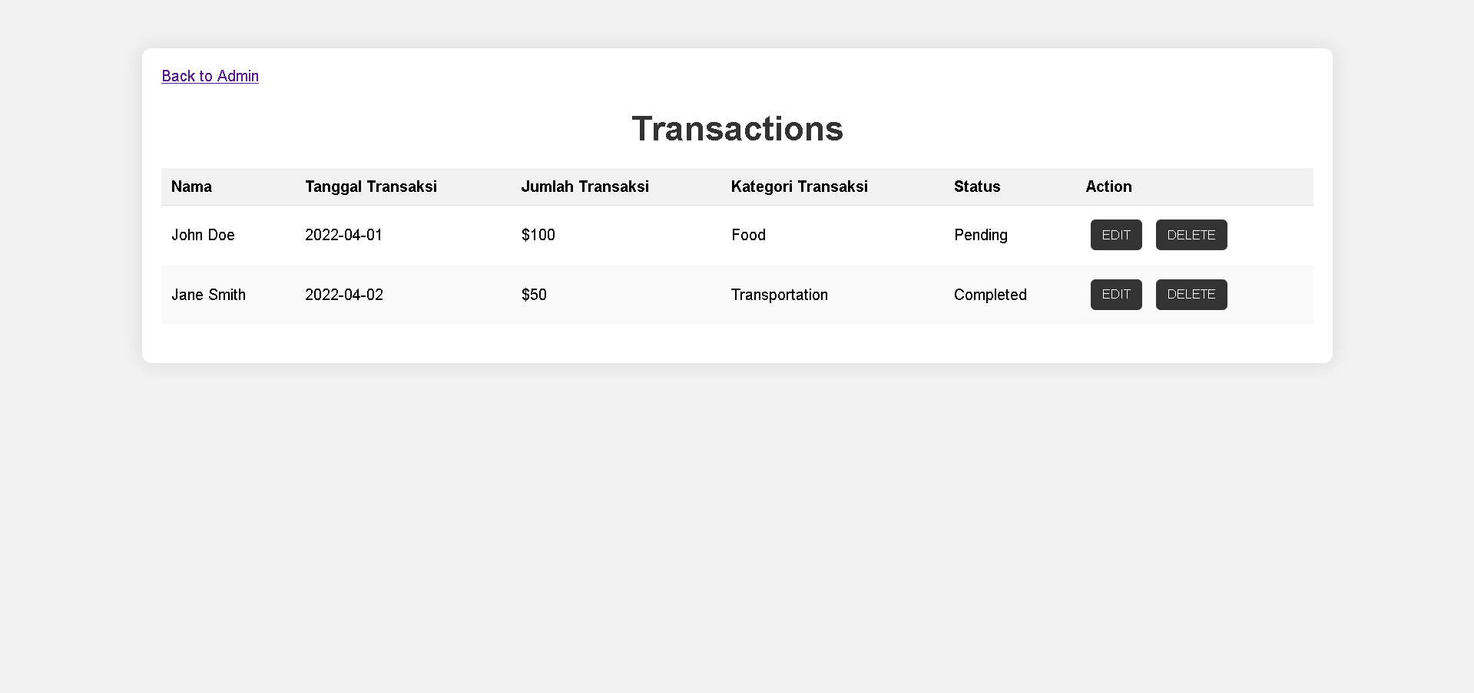

Gambar 1.6 Tampilan Transaction

Analisa :

Halaman di atas aaalah Transaction. Terdapat beberapa informasi yaitu nama, tanggal transaksi, jumlah transaksi, kategori transaksi, status dan action, lalu didalam action terdapa edit dan delete, serta terdapat back to admin yang Kembali ke menu dashboard atau admin